MAT216: Linear Algebra and Fourier Analysis

Section 1

Quiz

Total Marks: 30 marks

Name: _______________________ Student ID: _________________

**Q1:** Find the **LU-factorization** of the matrix.

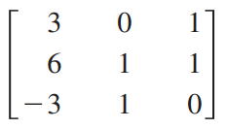

[10 Marks]

**Q2:** Solve the system using Gauss-Jordan elimination

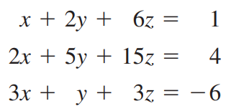

[10 Marks]

**Q3:** Find the inverse of the matrix.

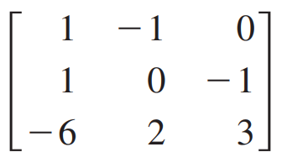

[10 Marks]